DEVELOPMENT CONTROL SECTION

DELEGATED PLANNING DECISION

Application No: 16/00040/COU
Location: 290 Holderness Road (Ground Floor), Kingston Upon Hull, HU9 2JX,
Proposal: Change of use from retail use to amusement centre, bingo and tanning (extension to the existing use at No. 288)
(Resubmission - Following ownership details changing)
Fee Paid: £0 - resub Fee Checked 1: CP Fee Checked 2:
Consultation Checked:
Recommended by: Date:
Authorised by: Date:

Target date 01.03.2016

Extension of time agreed to: 1) 2) 3)

Over 8/13 weeks because

PRINT DECISION NOTICE
Proof-read by: Date:
Final Check by: Date:
Decision Notice issued on:
Time taken (days)…………………….

Delegated Reports Only
Application No. 16/00040/COU
Address: 290 Holderness Road (Ground Floor), Kingston Upon Hull, HU9 2JX,
Dates: - Neighbour consults expire: 09.02.2016
Site notice consults expire: 16.02.2016
Press consults expire:
Date on Weekly List: 15.01.2016
Target date 01.03.2016
Member/Area Committee comment received
No
Extension of time agreed to (insert date):

SUMMARY
- Change of use to amusement centre - resub
- No objections received.
- Recommended for conditional approval.

SITE
A mid terraced 2 storey shop unit located on the south eastern side of the road. In use as a photo shop (Max Spielman). No. 292 to the north east is an amusement centre and No. 288, to the south west is also an amusement centre. There are a variety of shops in this terrace.
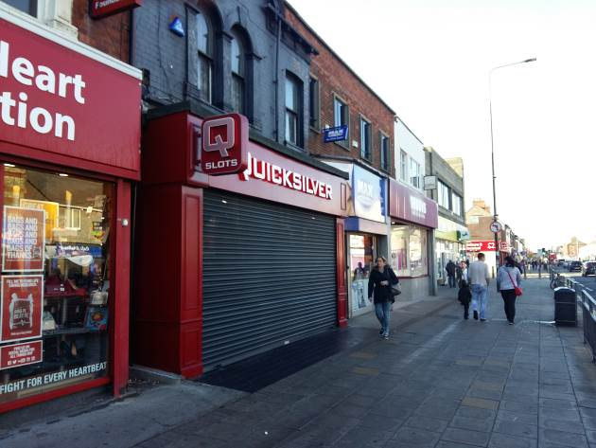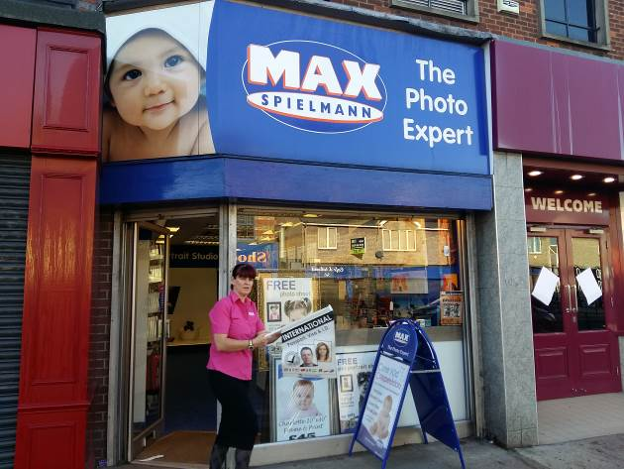
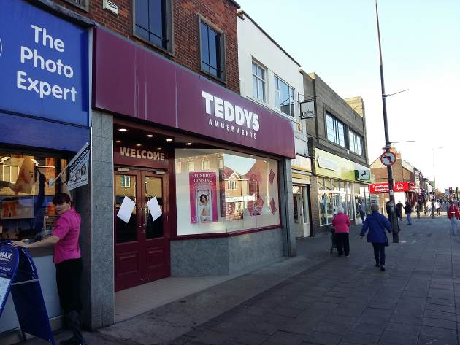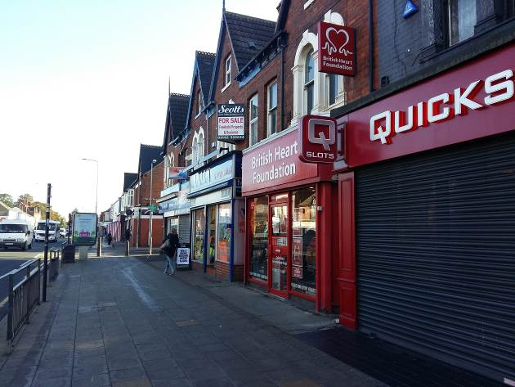

PROPOSAL
Change of use from retail use to amusement centre, bingo and tanning (extension to the existing use at No. 288)
(Resubmission - Following ownership details changing)

Relevant PLANNING HISTORY
15/01202/COU – Approved with Conditions 17.11.2015 - Change of use from retail use to amusement centre, bingo and tanning (extension to the existing use at No. 288)
288 Holderness Rd
03/01212/ADV – Approved with Conditions 30.10.2003 - Display of internally illuminated advertisement.
03/01211/FULL – Approved with Conditions 10.10.2003 - 1) Installation of new shopfront including roller shutter 2) Erection of rear extension.
03/01124/COU Approved with Conditions 07.10.2003 - Change of use of former retail shop to an amusement centre.
292 Holderness Rd
86/00528/PF – Approved with Conditions 16.06.1988 - Change of Use from shop to Leisure Centre comprising approximately 46 amusement machines and a snack bar
Plus others

REPRESENTATIONS
Waste Service
Requires Bins

APPLICANT’S CASE
Hull City Council recently granted planning permission in this case. Since permission was granted it has come to our attention that William Clark Ltd are not in fact the freehold owners and the Ownership Certificate supplied was therefore incorrect. The freehold of the property is owned by the associated company, Teddy Clark Ltd, and the applicants hold a lease.
In the circumstances there is a risk of the permission being challenged and I am therefore instructed to make a further application for planning permission which is in all respects (other than the ownership certificate) identical to the earlier one approved under reference 15/01202/COU.

The applicant has re-submitted the following supporting information:-

1. The application premises lie between 2 amusement centres run by different operators and the property is owned by the applicant. Obviously the proposal is for an expansion of an existing business not a new amusement centre.

2. The ground floor uses in the area and in this block are typically what is found in a district centre with a predominance of retail uses. There are presently 6 retail uses in the block (this would fall to 5 if the proposal is allowed), 1 x A2, 1 x A5 and two amusement centres (including the applicants which also has bingo and a popular tanning facility.

3. This proposal is part of a £250,000 refurbishment of Teddys premises; a substantial investment and vote of confidence in this centre by a major locally based employer.

4. The proposal will (among other things) give enhanced access to the tanning facility.

5. Max Spielmann have a lease which runs to June 2016. It is not intended to displace them before the end of the lease they signed up to. The applicant is the freeholder.

6. Our planning statement sets out the overall planning policy position in a more balanced way and considers all relevant local policies. We say the only conclusion one could come to looking at that overall position is that the proposal accords with the development plan and therefore enjoys a presumption in its favour.

7. Although it is suggested the area is 'characterised' by (inter alia) amusement centres you will, no doubt, be aware that the number, frontage and floorspace of amusement centres (including those operated by the applicant) in Holderness Road has declined considerably in recent years.

8. Should the tenant wish to retain representation in the centre there are ample opportunities in the form of shops which are vacant and/or on the market at present.

9. The floorspace (and frontage) involved in this case is very small indeed as will be apparent from the application plans and forms (57 sq metres gross).

PLANNING FRAMEWORK
Joint Structure Plan (June 2005): -
None directly relevant
Local Plan (May 2000 - saved policies 27 September 2007): -
Identified in the Local Plan as a District Shopping Centre
SI shopping development allowed
S2 - Existing shopping centres supported.
S5 - Shopping development allowed in existing shopping centres if it does not undermine vitality/viability of a shopping centre.
CF6 - Community facility development within shopping centres allowed if:
(i) It does not undermine shopping function of centre
(ii) ground floor frontage compatible with character of area.
Area Action Plans
Holderness Road Corridor Area Action Plan (March 2011)
Located in the Holderness Road District Centre
HRNBR5: Economic Development
The vitality and viability of the Holderness Road District Centre will be maintained and enhanced …
Other Material Considerations:-
NPPF6 Ensure the vitality of town centres (paras 23 to 27).
National Planning Policy Framework
None directly relevant
Safer Places- the Planning System and Crime Prevention (ODPM/Home Office, 2003)
Where proposed development would undermine crime prevention or the promotion of community safety and the concerns are relevant to land use planning, the application could be refused planning permission where refusal is consistent with the development plan

PLANNING APPRAISAL
This is a resubmission from the application approved in November 2015. To provide legal certainty the application has been re-submitted due to an error in the ownership identification. This does not affect the planning merits and the circumstances and policy have not changed since November 2015.
In terms of the principle of a non-retail use in this location the Local Plan and HRCAAP encourages such facilities to be located in existing larger shopping centres in order to secure a location with maximum accessibility by alternative means of transport to the private car and to encourage linked trips. It is not considered that the loss of a retail unit would adversely affect the retail function of this part of the District Centre. The proposal would be complementary to the shopping function of the District Centre and would help to secure vitality and viability.
Equalities
This proposal has been considered against the duty of the Council to consider equality issues. This development is considered to comply with these requirements because access is adequate.
Biodiversity
Not an issue in this case.
Crime and Disorder
Given the nature of the proposal it is considered that there would not be, or likely to be, an increase in crime or disorder or the potential for such an increase due to the location of the shop.
Energy efficiency and renewables
No implications.
Flood Risk
No implications.
Design and Conservation
Not within a Conservation Area and no heritage assets affected.
Conclusion
For the reasons outlined above it is considered that the proposal is acceptable.
DMPO Article 31 Statement
The local planning authority have worked with the applicant in a positive and proactive manner based on seeking solutions to problems arising in relation to dealing with the planning application in the following way(s):
Engaging in pre-application discussions with the applicants; and
Discussing potential solutions with the applicants during the processing of the application.

RECOMMENDATION
That the application be approved subject to the following conditions: -
- Det 2a (Time limit – Full application)
S:\Development Control\delegated reports\cp\16 00040 COU 290 Holderness Rd cou to amusement centre resub.docx

